PRESS RELEASE JDN104

NEW STAINLESS STEEL AIR HOIST CONCEPT
TO BE PREMIERED AT LOGIMAT 2016

Materials handling specialists J D Neuhaus will present their concept study of a stainless steel air hoist for the first time at the LogiMAT 2016 exhibition, taking place in Stuttgart from 8 – 10 March 2016. Exhibiting in Hall 6, Stand No. 6G60, the service side of the company will also present information on their comprehensive project planning and maintenance facilities.

Under the motto “engineered for extremes”, J D Neuhaus (JDN) pneumatic and hydraulic hoists and crane systems are used worldwide under the harshest of conditions: on drilling platforms, underground, in foundries, in arctic temperatures as low as -45°, or even under water. Extreme environmental conditions, no matter what the temperature, hot or cold, the performance of JDN products is not impeded.

But indoor uses can be just as extreme as these outdoor ones, namely in areas requiring extreme cleanliness and hygiene. JDN will present the conceptual study of a stainless steel air hoist at LogiMAT for exactly these areas. The sectors JDN is targeting with this study, which also provides for the use of food safe plastics, include for example, the food and drinks industry, chemical and pharmaceutical companies, together with medical and aerospace technology. The study combines the advantages of using compressed air as a method of operation with the hoist construction material of stainless steel. The products will therefore be resistant to corrosion and high levels of humidity, and also easy to clean and disinfect.

Continued ……
Even high-pressure cleaners pose no problem. As the out-going air is extracted and the chain is protected by a bellows, they can also be used in clean rooms (optical and semiconductor industries). And because compressed air is used as a method of operation, the hoist will also be explosion protected (ATEX) so that they can be used in potentially dangerous atmospheres or areas where organically flammable chemicals are handled.

JDN Service will also present its comprehensive offer for planning a project involving the maintenance and general work including overhauls of JDN products. For optimal parts supply, the JDN team has designed spare parts kits and general overhaul kits, which offer the customers a vastly improved service for ordering spare parts. The JDN Service Programme also offers training courses and, where necessary, rented hoists.

In addition, the company will also exhibit examples of standard JDN hoists with an extensive range of accessories and look forward to welcoming visitors to their stand.

Company Information
At its plant in Witten, Germany, J D Neuhaus GmbH & Co. produces pneumatically and hydraulically-operated hoists and crane systems with over 200 employees across the group. Thanks to this globally unique specialisation, J.D. Neuhaus has not only set the quality standard, but are also the world market leader with customers in more than 90 countries around the globe. The products particularly set themselves apart in their resilient and reliable operation thanks to their protection against explosions even in the most extreme operating conditions and capacities of up to 115 tonnes. For example, in oil and gas exploration in arctic temperatures as low as -45 °C, under water carrying out repairs on ships, in mining, in the chemical industry, in heavy plant construction and in many areas of logistics. J.D. Neuhaus supplies around 70 branches in total.

Production takes place exclusively at the Witten plant. The broad range of services provided includes equipment assembly, inspection, maintenance, and general overhaul, as well as running courses for customers.
Continued ……
For distribution, JDN companies in France, Great Britain, Singapore and the USA have created a tight-knit global network, in collaboration with international partners. The export rate is over 80%.
The founding of the company goes back to the year 1745, and it is now in its seventh generation of being family-run. At the Hebezeug-Museum (Hoist Museum) in Witten, one can see the history of this company as a living part of the business culture.

Further information is available on request to:
J D Neuhaus GmbH & Co. KG, 58449, Witten-Heven, Germany
Telephone: +49 2302 208-219 Fax: +49 2302 208-286
e-mail: info@jdngroup.com www.jdngroup.com

Worldwide contact details for J D Neuhaus can be seen at the end of this press release.

facebook.com/jdneuhaus www.jdngroup.com/plus

(approximately 700 words
including photographic annotations)

General Info rmation

Supplier: J. D. Neuhaus GmbH & Co. KG

Press Release No: JDN104

Press or publishing inquiries to: Steve Lloyd
Enterprise Marketing Services Ltd
The Coach House, 1 Dunstall Road, Barton under Needwood,
Burton on Trent, Staffordshire, DE13 8AX, UK
Tel: +44 (0) 1283 713185
Fax: +44 (0) 1283 716172
e-mail: info@enterprise-marketing.co.uk

Reader response inquiries to: Mr Manfred Müller of J D Neuhaus GmbH & Co. KG

Downloads: The press release text (MS Word and PDF format) and images are
available for download at:

www.enterprise-marketing.co.uk/jdn/jdn104.html

Our Reference: JDN104/16/01/V2

Continued ……
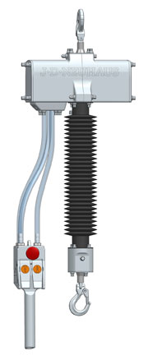

Conceptual study for a stainless steel air hoist.
Download high resolution 300dpi image
Download low resolution 72dpi image

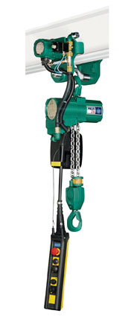

JDN air hoist Profi 2 TI in motor trolley
Download high resolution 300dpi image
Download low resolution 72dpi image
Continued ……
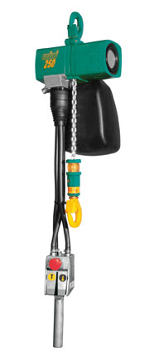

JDN air hoist mini 250
Download high resolution 300dpi image
Download low resolution 72dpi image

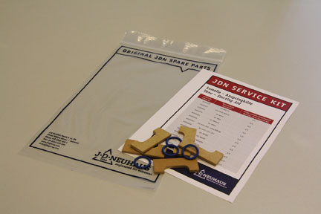

Starting Aid Service Kit
Download high resolution 300dpi image
Download low resolution 72dpi image

Continued …...
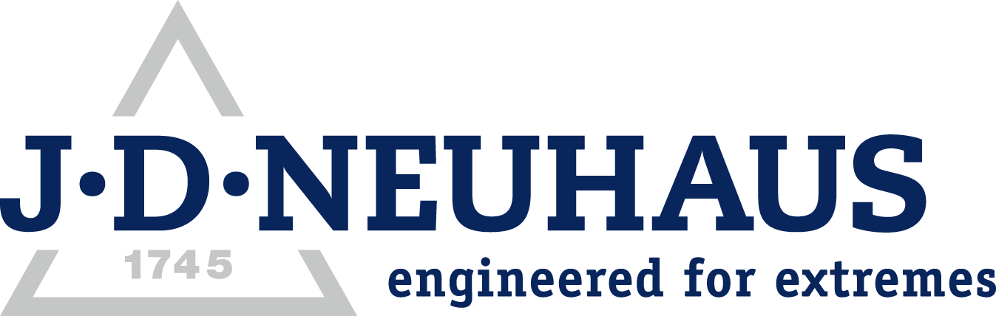
Company information

J D Neuhaus are a privately-owned company, founded in 1745, and for over 270 years they have been using their expertise and experience to manufacture the highest quality hoists and cranes.

Their products offer solutions to almost every material handling problem irrespective of the driving medium: from air and hydraulic hoists up to complete crane installations with explosion proofness.

JDN products are used in a wide variety of industries including:
Airplane Yards; Atomic/Coal Power Stations; Big Bag Handling; Cement Industry; Chemical Industry;
Crane Manufacturers; Dairies; Food Industry; Foundries; Galvanisation; Glass/Ceramics; Large Kitchens;
Leather Plants; Locks; Machine and Plant Construction; Mining; Motor Car Industry; Offshore/Onshore;
Oil Storage; Over/Underground Construction; Paints and Varnish; Painting and Coating Installations;
Paper Industry; Pharmaceutical Industry; Printing Industry; Pyrotechnics Industries; Refineries; Sawmills; Shipbuilding and Shiprepair Yards; Ships; Space Technique; Spray Booths; Steel Works; Surface Technique;
Tank Cleaning Devices; Textile Industry; Tunnel; Tyre Manufacturers; Vacuum Technique

Contact J D Neuhaus

J D Neuhaus are represented in more than 90 countries and over 70 branches Worldwide.

Germany
J D Neuhaus GmbH & Co. KG, 58449, Witten-Heven, Germany
Tel: +49 2302 208-219 Fax: +49 2302 208-286
e-mail: info@jdngroup.com www.jdngroup.com

France
J D Neuhaus S.A.R.L., 24, rue du Président Krüger, 69008, Lyon, France
Tel: +33 4 3790-1745 Fax: +33 4 3790-1746
e-mail: info@jdneuhaus.fr www.jdngroup.com

Great Britain
J D Neuhaus Ltd, Unit 6 Kirkton Avenue, Pitmedden Road Industrial Estate, Dyce, Aberdeen, AB21 0BF, UK
Tel: +44 1224 722751 Fax: +44 1224 729895
e-mail: info@jdneuhaus.co.uk www.jdngroup.com

Singapore
J.D. Neuhaus Pte. Ltd, 21 Toh Guan Road East, #09-02 Toh Guan Centre, 608609, Singapore
Tel: +65 62758911 Fax: +65 62758922
e-mail: info@jdn.com.sg www.jdngroup.com

USA
J.D. Neuhaus L.P., 9 Loveton Circle, MD 21152 Sparks, USA
Tel: +1-410 472-0500 Fax: +1-410 472-2202
e-mail: info@jdneuhaus.com www.jdngroup.com

